# Exercises: Razor Engine – Part 2

Problems for exercises and homework for the [“C# MVC Frameworks - ASP.NET” course @ SoftUni](https://softuni.bg/trainings/1537/csharp-mvc-frameworks-asp-net-march-2017).

## Profile Page Layout

**Change** the **layout** of the **profile page**. The navigational bar on the top should no longer be there. Instead move it to the **left** of the page and display the information of the profile on the **right** of the screen. Also, add a **footer** on the right under the profile information of the user.

### Example

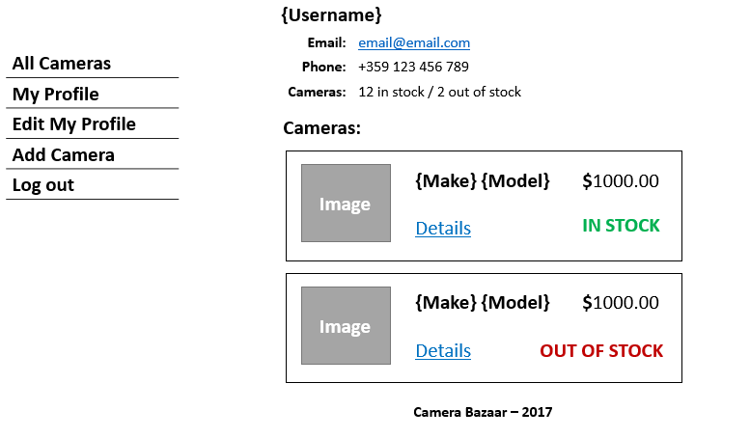

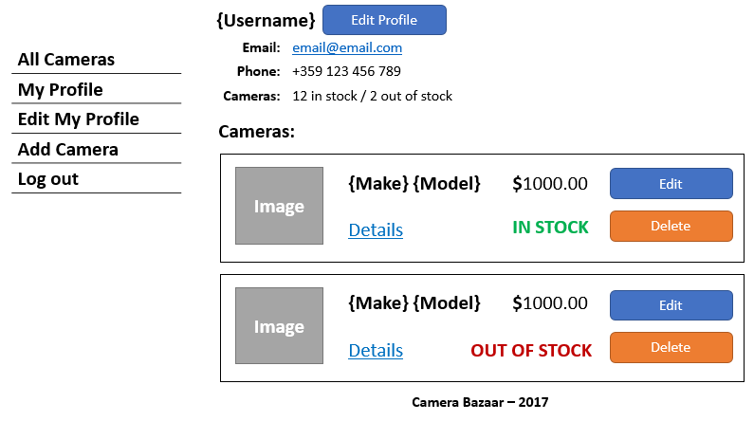

## Last Login Time

When the user is logged in he should be able to **see the last time he logged in** on his **profile** and **edit profile pages**. If this is the first-time user has ever logged in display “First log in”. Avoid code duplication.

### Example

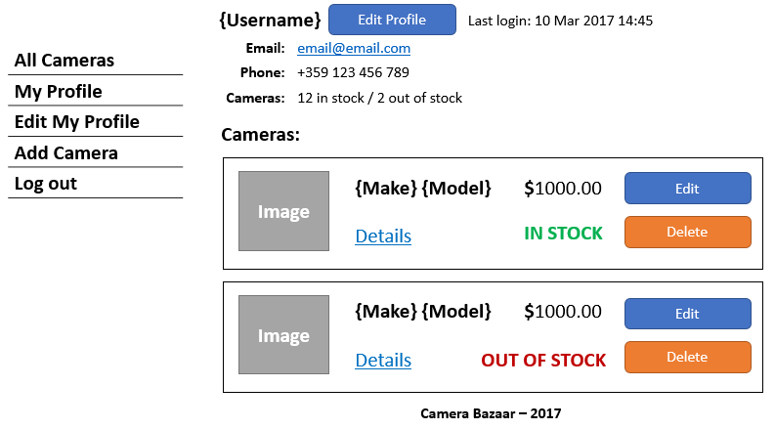

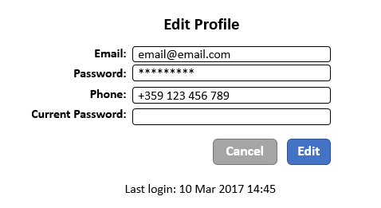

## Camera Characteristics

Refactor the code of the view for **camera details**. Move the **characteristics of a camera** to a **new partial view** so the camera details view don’t be so big.